**LECTURE 2 CREATING A BASIC WEB API PROJECT IN VISUAL STUDIO**

* Open Visual Studio.
* Go to **File > New > Project.**
* Click on **Web > ASP.NET Web Application (.NET Framework).**
* Name the API **TestProject** and then click on **OK**.

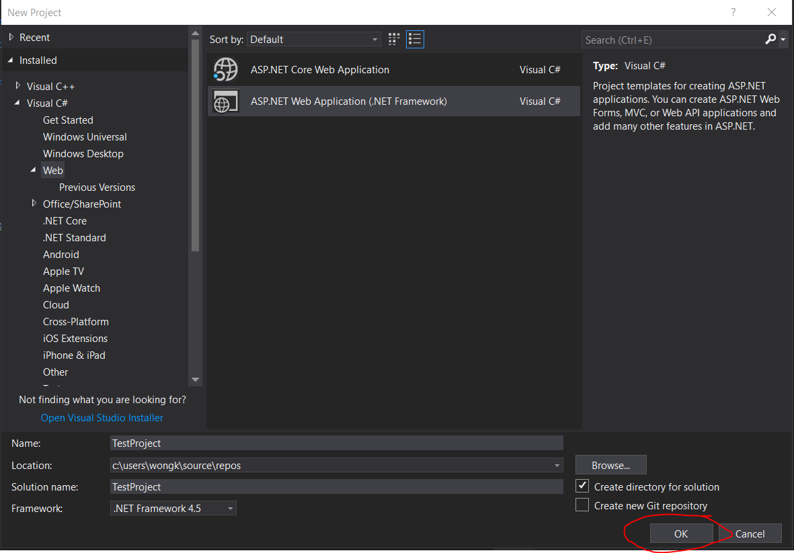

* Select the **Empty** template and then select the **Web API** checkbox then click on **OK**.

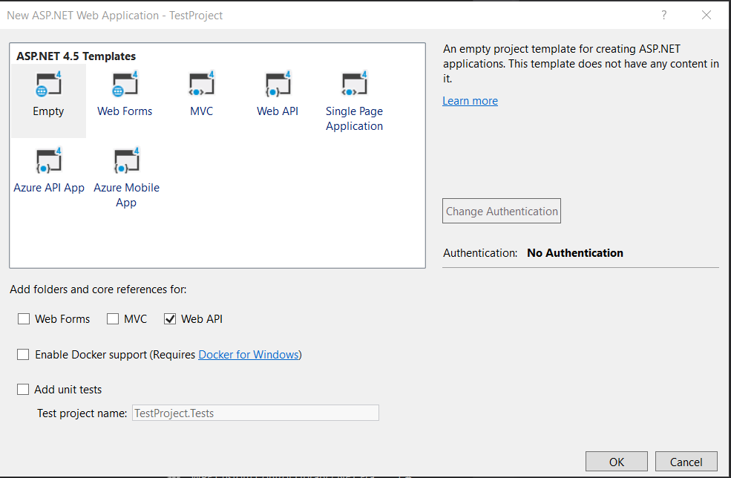

* Now we are going to create a Controller.
* On the **Controller** folder, right click it and then select **Add > Controller**.
* Then select  **Web API 2 Controller with read/write actions** and press **Add**.

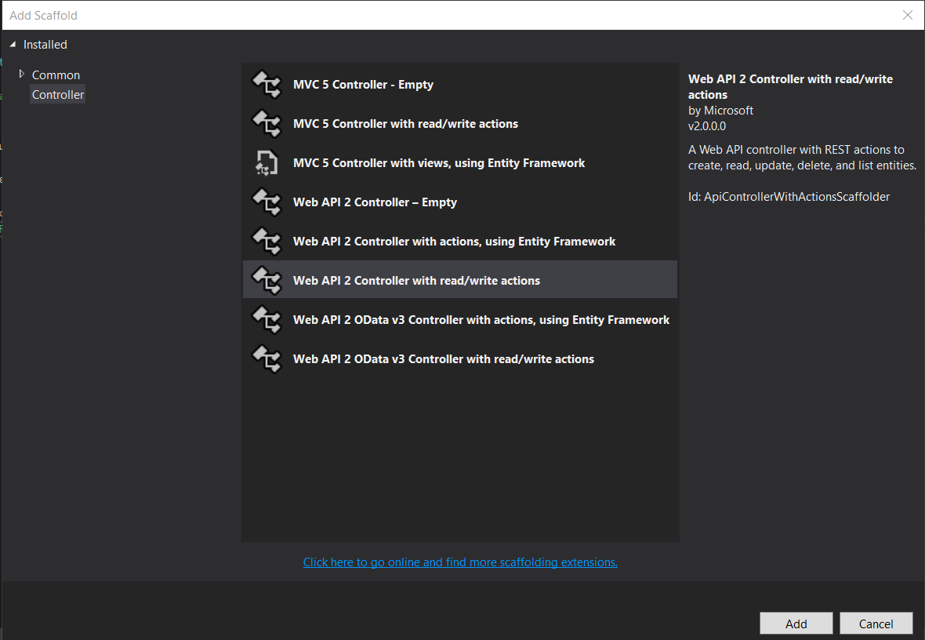

* Name the Controller **ValuesController** and click **Add**.

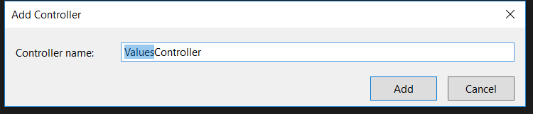

* Press **F5** to compile and run the project.
* In the browser in the URL type **localhost:54764/api/Values** and you should get an XML file with the values from the API in there.

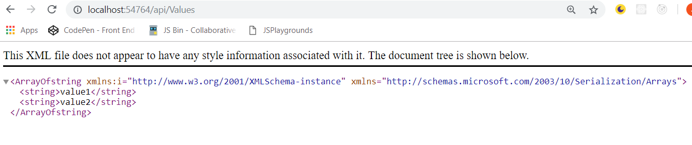

**LECTURE 3 – ALTERNATIVE STARTING POINT: AZURE API APP TEMPLATE**

* Now we are going to take a look at an alternative to the empty template of the web api. This template is designed for Azure Apps.
* In VS Studio, click on **File > New > Project**.
* Select **Web > ASP.NET Web Application (.NET Framework)**.
* Name the application **TestProject2** and click on **OK**.

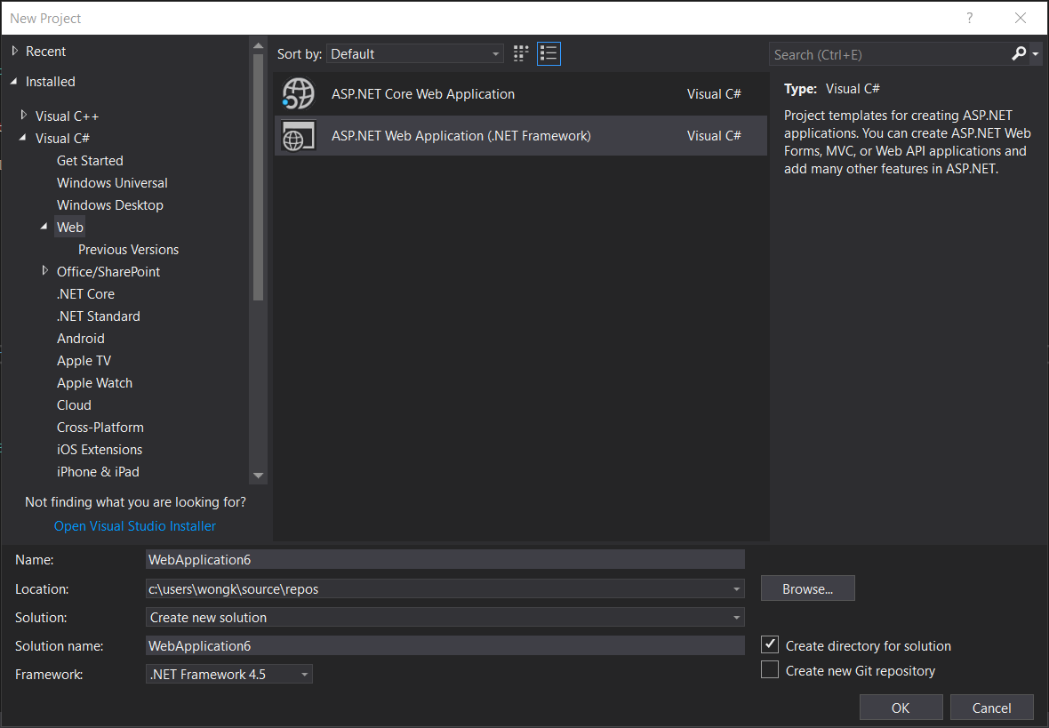

* Select **Azure API App** and click on **OK**.

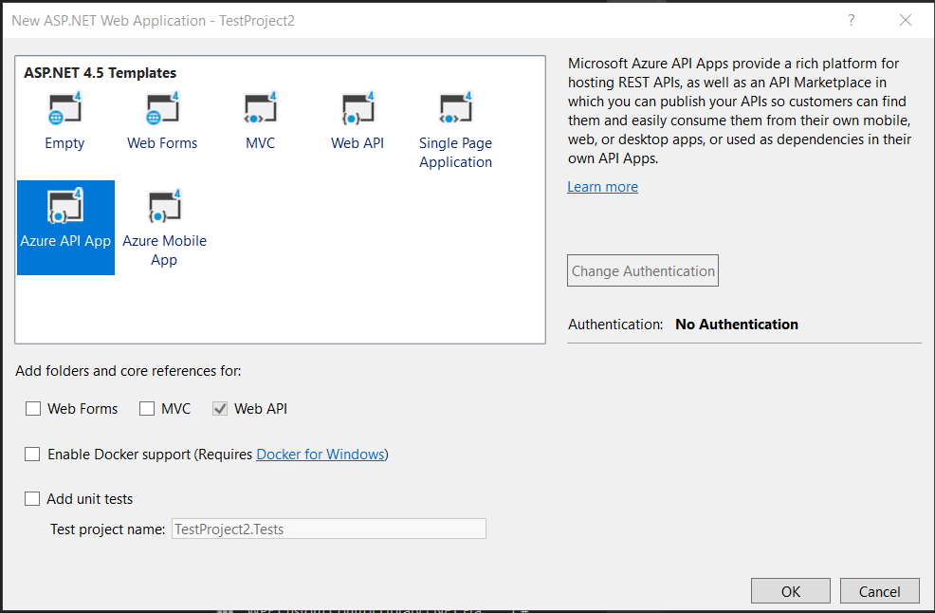

**LECTURE 5 – SECTION 2 INTRODUCTION**

* Gdsf
* G
* Sdfg
* Fsdh
* Asdf
* Ads
* Gfas
* Dgas
* Dg
* Fdsf
* Dsaf
* Adsf
* Adsf
* Asd
* Fasd
* Fas
* Fa
* Sf
* Asf
* Asd
* A
* Sdfds
* Fa
* Sf
* Af
* Asd
* Fasd
* Afds
* Fsad
* F
* Adsf
* Asf
* S
* Fd
* Sf
* Asdf
* Asd
* Fads
* F
* Dasf
* Asdf
* Asd
* Afds
* F
* Adsf
* Asd
* Fasd
* Fads
* Fasd
* F
* Asdf
* Ads
* Fas
* Df
* Asd
* Fas
* Fa
* Sdf
* Asdf
* Sd
* Fa
* Fs
* Asdf
* As
* Dfa
* Sdf